

**CT126-3-2-CTF-PRACTICAL CTF STRATEGIES**

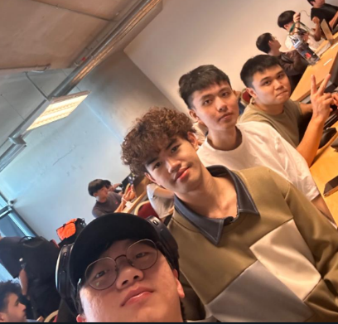**GROUP ASSIGNMENT (40%)**

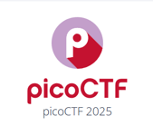

**picoCTF 2025 Mar 8, 2025 – Mar 18, 2025**

|  |  |
| --- | --- |
| **GROUP NAME:** | **Group 23 (forfun)** |
| **TP NUMBER** | **NAME** |
| TP080121 | Yaw Kai Yuan |
| TP080254 | Er Chen Liang |
| TP080388 | Chong Wai Kit |
| TP077723 | Huang Xiao Shun |

Table of Contents

1. Introduction 7

1.1 Overview of the CTF Live Competition 7

1.2 Rules 9

1.3 Prizes and Eligibility 10

1.4 Team Name and Team Members 12

1.5 Approval of Challenge and Reflection 14

2. Challenge Description 15

2.1 Challenge 1 - Guess My Cheese (Part 2) 15

2.1.1 Accessing the Challenge via netcat 18

2.2 Challenge 2 - hash-only-2 20

2.2.1 Accessing the Challenge via ssh 22

3. Step-by-step Solutions 23

3.1 Guess My Cheese (Part 2) 23

3.1.1 Download the files 23

3.1.2 Analysis the files 24

3.1.3 Analysis the hash value 25

3.1.4 Determine the solution idea 28

3.1.5 Python Script Implementation 29

3.1.6 Guess the Cheese 33

3.1.7 Submit the Flag 35

3.2 Hash-only-2 36

3.2.1 Launch the challenge 36

3.2.2 Locate the flaghasher 37

3.2.3 Determine the solution idea 38

3.2.4 Implementation of various codes 39

3.2.5 Bypassing Restrictions and Hijacking the MD5sum 40

3.2.6 Submit the Flag 43

4. Tools, Command and Script Used 44

4.1 Webshell 44

4.2 Netcat 45

4.3 ChatGPT 46

4.4 Python Programming Language 49

4.5 PyCharm 51

4.6 Secure Shell (SSH) 52

4.7 PATH Hijacking and Command Substitution 53

4.8 env Command 54

5. Vulnerabilities and Exploitations of the Challenge 55

5.1 Guess My Cheese (Part 2) 55

5.2 hash-only-2 56

6. Knowledge and Skills Learned 57

7. Challenges Faced 58

7.1 Guess My Cheese (Part 2) 58

7.1.1 Using online hash cracker tools 58

7.1.2 Hashcat not working 60

7.1.3 Misunderstanding the meaning of salt 63

7.2 Hash-only-2 66

7.2.1 Difficulty Locating the Binary of flaghasher 66

7.2.2 Misunderstanding of the Access Permission 68

7.2.3 Overcoming the rbash restriction 69

8. Lesson Learned 70

9. Summary – ELIF (Explain Like I’m Five) 71

9.1 The Secret Recipe 71

9.2 The Escape Room Trap 72

10. Workload Matrix 73

11. References 74

Table of Figures

Figure 1 - Overview of the picoCTF (Carnegie Mellon University, 2025) 7

Figure 2- picoCTF 2025 Scoreboard (Carnegie Mellon University, 2025) 8

Figure 3- picoCTF 2025 Rules (Carnegie Mellon University, 2025) 9

Figure 4- picoCTF 2025 prizes (Carnegie Mellon University, 2025) 10

Figure 5 - picoCTF 2025 prizes (Carnegie Mellon University, 2025) 10

Figure 6 - picoCTF 2025 prizes (Carnegie Mellon University, 2025) 11

Figure 7 - picoCTF 2025 Team Member's 12

Figure 8 - Ranking in picoCTF 2025 13

Figure 9 - Lecture Approval 14

Figure 10 - Guess My Cheese (Part 2) 15

Figure 11 - Points of Guess My Cheese (Part 2) 15

Figure 12 - Guess My Cheese (Part 2) Hint 1 16

Figure 13 - Guess My Cheese (Part 2) Hint 2 16

Figure 14 - Guess My Cheese (Part 2) Hint 3 17

Figure 15 - picoCTF Webshell 18

Figure 16- Access the Guess My Cheese Challenge 18

Figure 17 - Challenge Detail 18

Figure 18 - Failed to Guess the Cheese 19

Figure 19 - Challenge hash-only-2 20

Figure 20 – Points of Hash-only-2 Challenge 20

Figure 21 - Launch Instance 21

Figure 22 - Hash-only-1 Challenge 21

Figure 23 – Access picoCTF Webshell 22

Figure 24 - picoCTF Webshell 22

Figure 25 - cheese_list.txt 23

Figure 26 - cheese_list.txt 24

Figure 27 - Guess my Cheese (Part 2) Description 25

Figure 28 - Asking ChatGPT what salt means 26

Figure 29 - ChatGPT Prompt 27

Figure 30 - Python Script 29

Figure 31 - Python Script 30

Figure 32 - Python Script 31

Figure 33 - Python Script Output 32

Figure 34 - Enter Answer in Webshell 33

Figure 35 - Capture the Flag 34

Figure 36 - Submit the Flag 35

Figure 37 - Access hash-only-2 in webshell 36

Figure 38 - Locate the flaghasher 37

Figure 39 - Find the flaghasher 38

Figure 40 - Which is the flaghasher directory 39

Figure 41 - Where is the flaghasher directory 39

Figure 42 - Execute flaghasher 39

Figure 43 - Replace MD5 hash 40

Figure 44 - Change file permission 40

Figure 45 – Escape the limitations of rbash 40

Figure 46 - Asking ChatGPT how to bypass 41

Figure 47 - ChatGPT Prompt 42

Figure 48 - Look for /home/ctf-player path 42

Figure 49 - Capture the Flag 42

Figure 50 - Submit the Hash-only-2 Flag 43

Figure 51 - Webshell 44

Figure 52 – ChatGPT (Hetler, 2025) 46

Figure 53 - ChatGPT Prompt 47

Figure 54 – Python (W3Schools, n.d.) 49

Figure 55 - Python Script 50

Figure 56 – PyCharm (GeeksforGeeks, 2023) 51

Figure 57 - Example Using env commands 54

Figure 58 - Online Hash Cracker Tool (CrackStation, n.d.) 58

Figure 59 - Online Reverse Hash Tool (MD5Hashing, n.d.) 59

Figure 60 - Asking ChatGPT Generate Script 60

Figure 61 - ChatGPT Prompt 60

Figure 62 – Script Output 61

Figure 63 - Using Hash cat commands 61

Figure 64 - Failed to Start Brute Force 62

Figure 65 - Wrong Python Script 63

Figure 66 - Output 63

Figure 67 - Try to crack our generated hash 64

Figure 68 - Output 64

Figure 69 - ChatGPT Prompt 65

Figure 70 - Try to find the flaghasher 66

Figure 71 - Asking ChatGPT for idea 66

Figure 72 - ChatGPT Prompt 67

Figure 73 - Restricted by rbash 68

Figure 74 – Confused and Asked ChatGPT 68

Figure 75 - Restricted by rbash 69

Figure 76 - Asking ChatGPT how to bypass 69

Figure 77 - Bypass Command 69

Figure 78 - The Secret Recipe 71

Figure 79 - The Escape Room Trap 72

# 1. Introduction

## 1.1 Overview of the CTF Live Competition

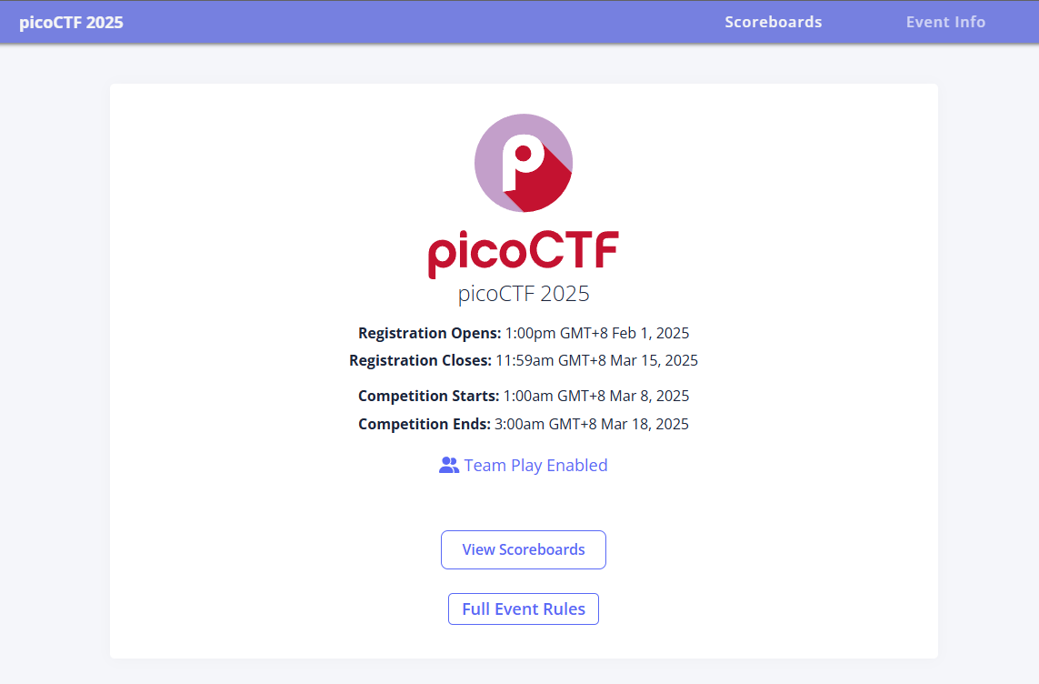

Figure 1 - Overview of the picoCTF (Carnegie Mellon University, 2025)

The picoCTF 2025 is an online capture-the-flag competition hosted by Carnegie Mellon University to enhance cybersecurity skills among middle school, high school, and college students. This CTF is a jeopardy-style challenge where you can solve it independently to get points through the internet or the on-site network (CTF Wiki, n.d.). The challenges come from six domains of cybersecurity, including general skills, cryptography, web exploitation, forensics, binary exploitation and reversing. The challenges are designed to be hacked so it's a great way to get real-world experience. The registration for the competition will be closed in the last three days of the competition, which is more convenient in terms of time.

The participants are divided into five categories: Global, US Middle/high school, US middle school, Africa HS/Undergraduate, JP students. All other regions except those mentioned will be classified in Global. When registering for the competition, you need to agree to the rules and verify your identity, otherwise you will not be able to participate. The player needs to register an account on the [picoCTF - Sign Up](https://play.picoctf.org/register) before you can participate in the competition. This competition can participate in independently or in a team of up to 5 people.

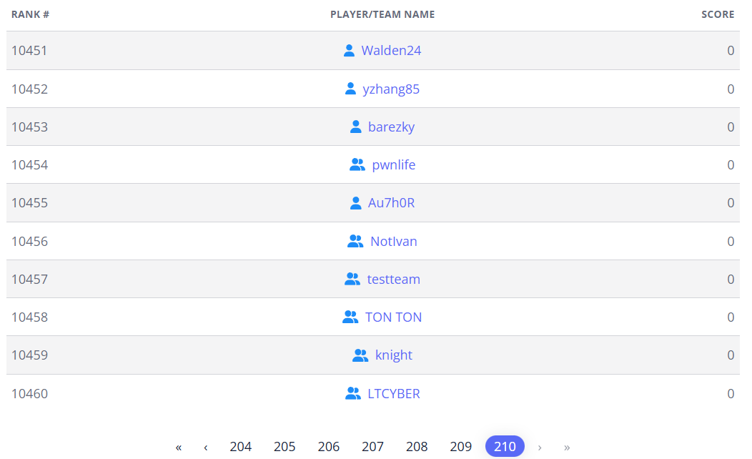

Figure 2- picoCTF 2025 Scoreboard (Carnegie Mellon University, 2025)

According to the standings, there are 10,460 teams participating in this competition. It is a very competitive competition that makes participants feel excited to compete for the prize.

## 1.2 Rules

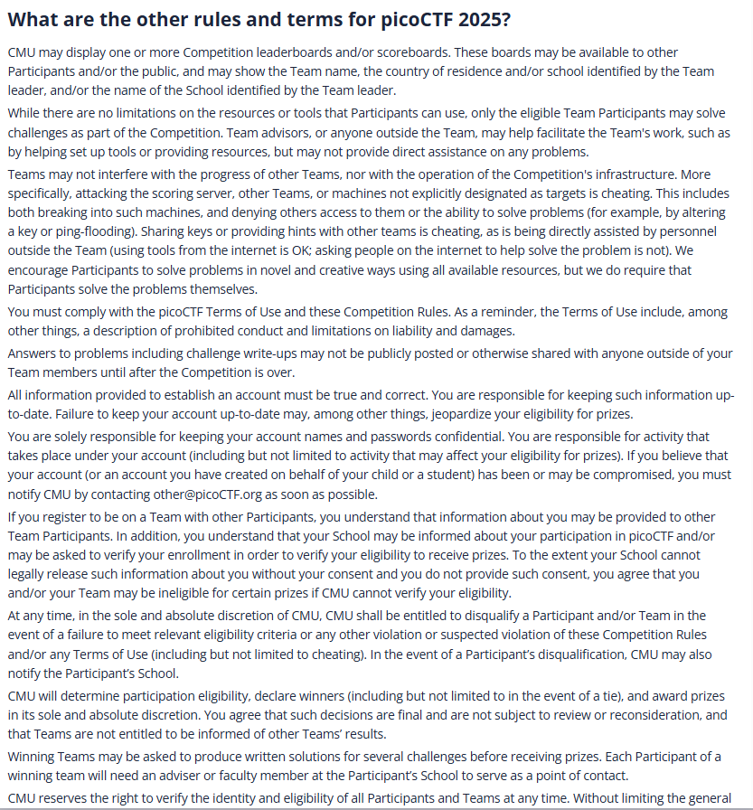

Figure 3- picoCTF 2025 Rules (Carnegie Mellon University, 2025)

The main rule of this competition is that you cannot attack the scoring server or other teams. This includes hacking into such machines, as well as preventing others from accessing or solving problems. Sharing the flag with others and accepting direct assistance from people outside the team are also cheating (using Internet tools is allowed; asking Internet people for help to solve problems is not cheating). The answers to any challenges cannot be made public before the end of the competition. The organizer has the right to disqualify the team if any rules are violated (Carnegie Mellon University, 2025).

## 1.3 Prizes and Eligibility

The team that solves the most problems within the allotted time will be the winner. If more than one team solves all of the problems, then the team that solved the problems in the shortest amount of time will be the winner (Carnegie Mellon University, 2025). The first place team in the US middle/high school category will receive $3000 USD, the second place $2000 USD, and the third place $1000 USD. The first place team in the US middle school category will receive 500 USD, the second place 300 USD, and the third place 150 USD. Teams in the Africa HS/Undergraduate and JP student's categories will receive prizes from their sponsors Cylab Africa and CognitiveHack Japan. Unfortunately, teams that are not in the above regions and are classified in the Global category are not eligible for prizes.

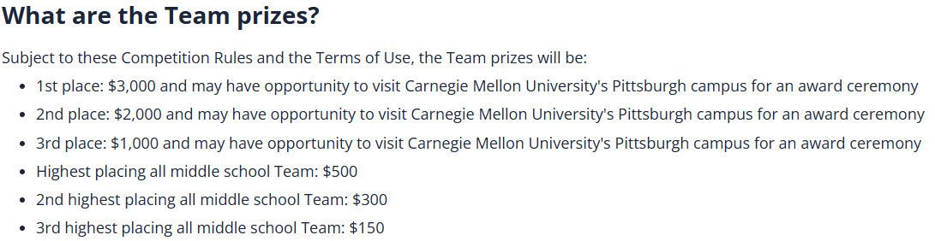

Figure 4- picoCTF 2025 prizes (Carnegie Mellon University, 2025)

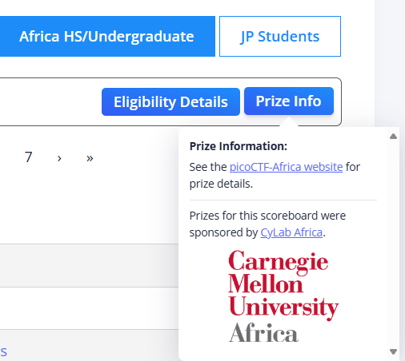

Figure 5 - picoCTF 2025 prizes (Carnegie Mellon University, 2025)

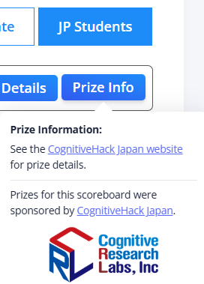

Figure 6 - picoCTF 2025 prizes (Carnegie Mellon University, 2025)

## 1.4 Team Name and Team Members

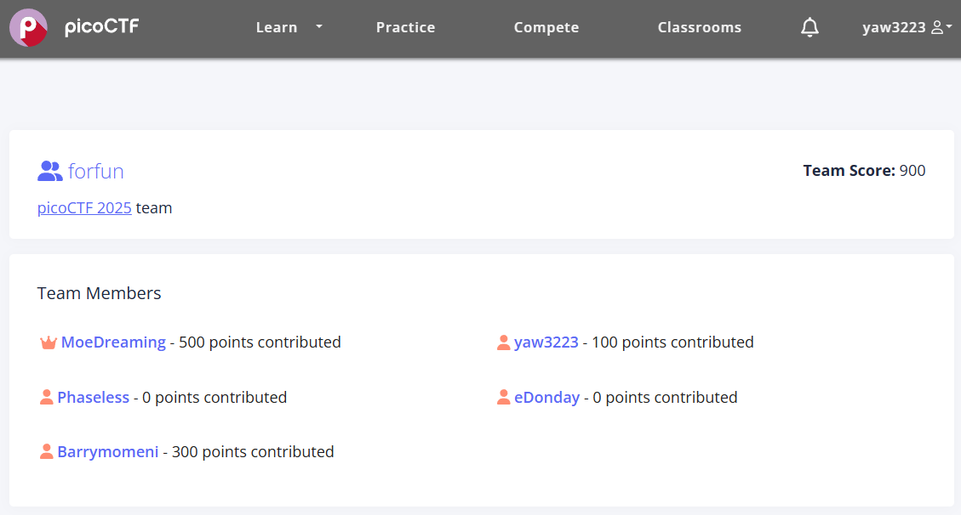

Figure 7 - picoCTF 2025 Team Member's

Our team, forfun, was formed by Yaw Kai Yuan (yaw3223), Er Chen Liang (MoeDreaming), Chong Wai Kit (Phaseless), Huang Xiao Shun (eDonday). We choose forfun as the team's name for fun of learning, exploring, and solving cybersecurity challenges together. As a team, we can easily assign tasks to each team member to solve challenges, allowing each team member to use their own technical skills. We participated in the picoCTF 2025 competition to enhance our cybersecurity skills and gain professional knowledge in this field. Although we are all beginner, the knowledge and skills we learned during the competition are very meaningful.

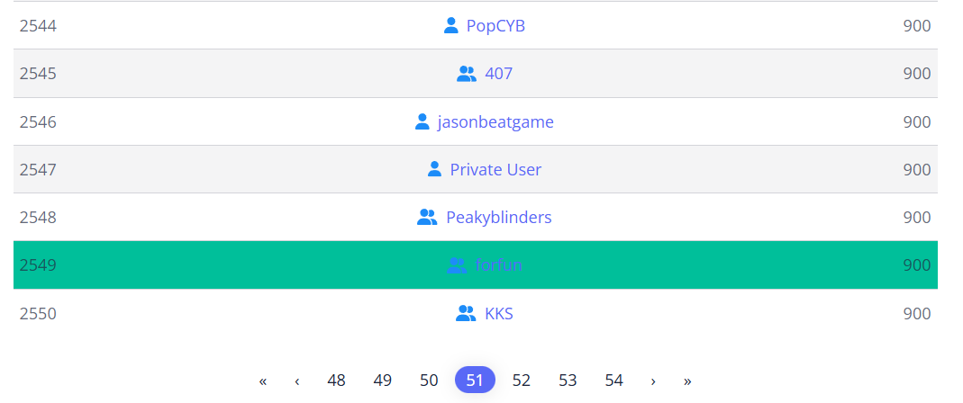

Figure 8 - Ranking in picoCTF 2025

In the end, our team won the 2549th place in the competition. Compared with more than 10,000 participating teams, our score was in the top 25%, which was a good result for us beginners and motivated us to get a higher ranking in the next competition.

## 1.5 Approval of Challenge and Reflection

Before participating in the picoCTF 2025 competition, we received an announcement from our lecture, Mr. MOHD HANIS BIN JENALIS that there is a competition to challenge our cybersecurity skills. We also got approval from lecture. This competition provides us with a platform to implement the cybersecurity skills and knowledge we learned in class and to work with the team to solve problems. The reason why we chose guess my cheese part is that the guess my cheese topic is very interesting and there are many different cheese names. It involves cryptography, which requires understanding the encryption process, and you need to have a good understanding of cryptography. Next, we chose the challenge hash-only-2 because our team is very confident that we can solve this challenge. It involves finding a vulnerability in the program and exploiting it. After participating in the picoCTF 2025 competition, although we lack experience, we have also learned a lot of technical skills. Besides, Jeopardy-style CTF competitions are friendly to new players and wide coverage of topics gives us flexibility.

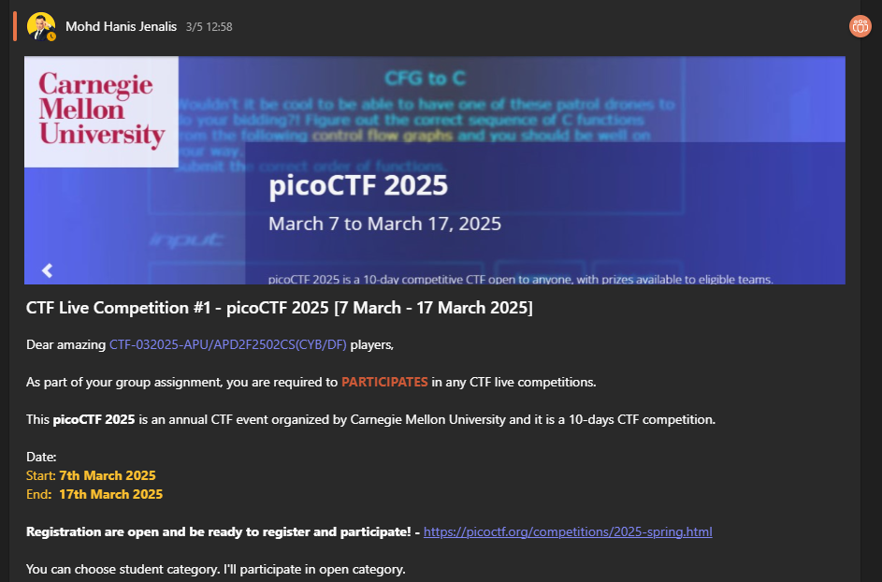

Figure 9 - Lecture Approval

# 2. Challenge Description

## 2.1 Challenge 1 - Guess My Cheese (Part 2)

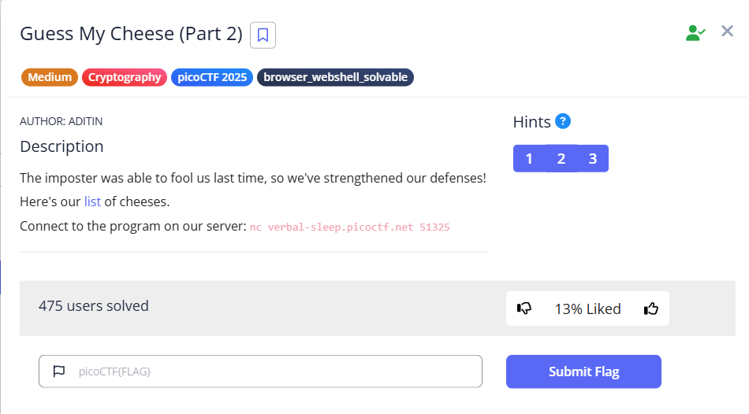

Figure 10 - Guess My Cheese (Part 2)

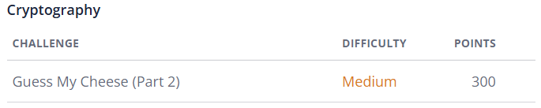

Figure 11 - Points of Guess My Cheese (Part 2)

* Challenge Name: Guess My Cheese (Part 2)
* Category: Cryptography
* Level: Medium (300 points)
* Challenge Description: The imposter was able to fool us last time, so we've strengthened our defenses!

Here's our list of cheeses.

Connect to the program on our server: nc verbal-sleep.picoctf.net 51325

The challenge is presented in a fun way to guess the correct cheese name. This challenge is given a cheese_list.txt file. The challenge needs to be connected to the challenge using the nc command to see the content of the challenge. The challenge will give us a hash value and the plain text of the hash value is one of the cheeses on the given cheese list. This challenge has 300 points which is a very high score in this competition. It requires a team with knowledge and skills to crack it.

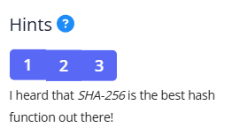

Figure 12 - Guess My Cheese (Part 2) Hint 1

This hint says that the hash value of this challenge is related to sha256 hash.

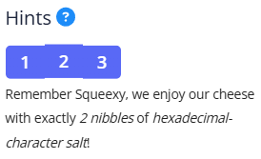

Figure 13 - Guess My Cheese (Part 2) Hint 2

This hint means that the salt is represented by 2 hexadecimal characters, so the salt value has 256 possibilities.

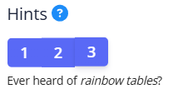

Figure 14 - Guess My Cheese (Part 2) Hint 3

This hint suggests using a rainbow tables, which is a table of common input hash values ​​that are pre-calculated.

In addition, the challenge provides three hints to help find the flag. These hints help team members think in the right direction when solving the problem.

### 2.1.1 Accessing the Challenge via netcat

This webshell is provided by picoCTF platform and is like a kali linux system.



Figure 15 - picoCTF Webshell

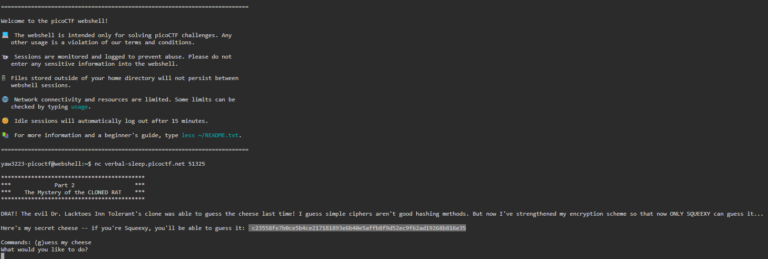

Figure 16- Access the Guess My Cheese Challenge

Used the picoCTF webshell to connect to the challenge and typed nc verbal-sleep.picoctf.net 51325 to see the content of the challenge. We need to enter the g character first.

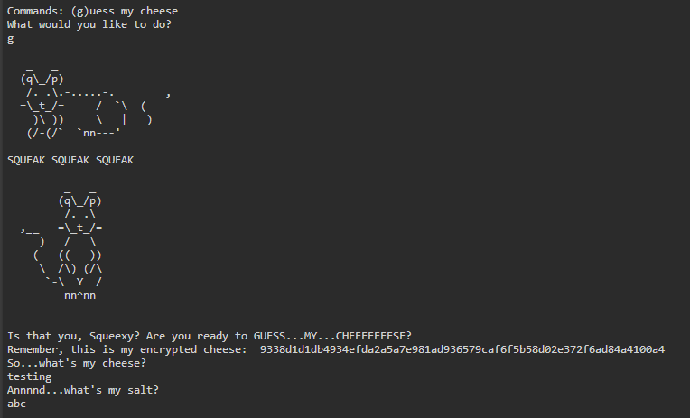

Figure 17 - Challenge Detail

After entering the g character, you need to enter the correct cheese name and what salt is.

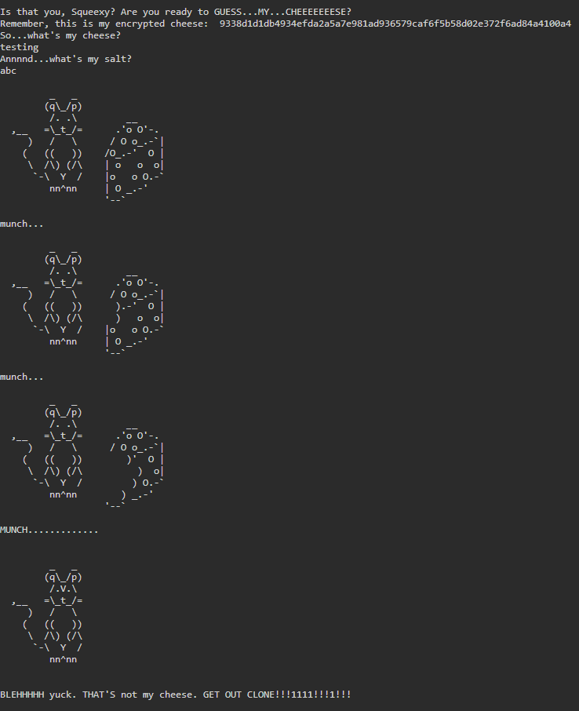

Figure 18 - Failed to Guess the Cheese

This is the output if one of the answers are incorrect. The entire challenge will be reset and the hash value given next time when connecting to this challenge will be different. This is a difficult challenge because you can’t figure out the answer by guessing the same hash value repeatedly.

## 2.2 Challenge 2 - hash-only-2

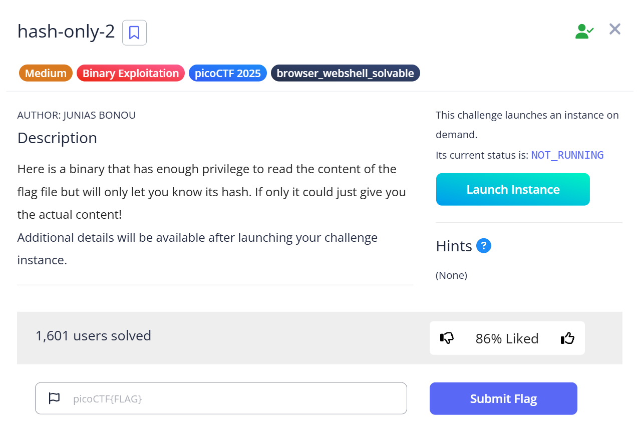

Figure 19 - Challenge hash-only-2



Figure 20 – Points of Hash-only-2 Challenge

* Challenge Name: hash-only-2
* Category: Binary Exploitation
* Level: Medium (200 points)
* Challenge Description: Here is a binary that has enough privilege to read the content of the flag file but will only let you know its hash. If only it could just give you the actual content! Additional details will be available after launching your challenge instance.

This challenge will give us the ssh command only when we launch it. After that, when we start the challenge, we can use the ssh command and password given which can let us access the “flaghasher” inside the web shell. At this time, we can try to find out how we can get the flag. This challenge got 200 points on it which really given a great score in this competition.

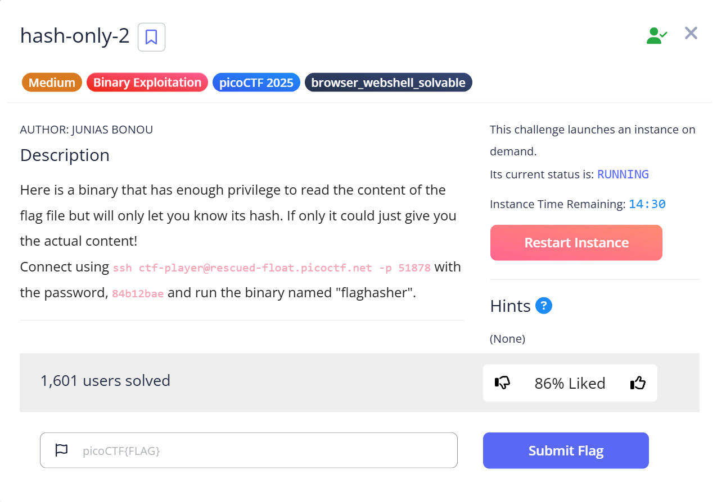

Figure 21 - Launch Instance

Connect using ssh ctf-player@rescued-float.picoctf.net -p 51878 with the password, 84b12bae and run the binary named "flaghasher". No hints are given in this challenge.

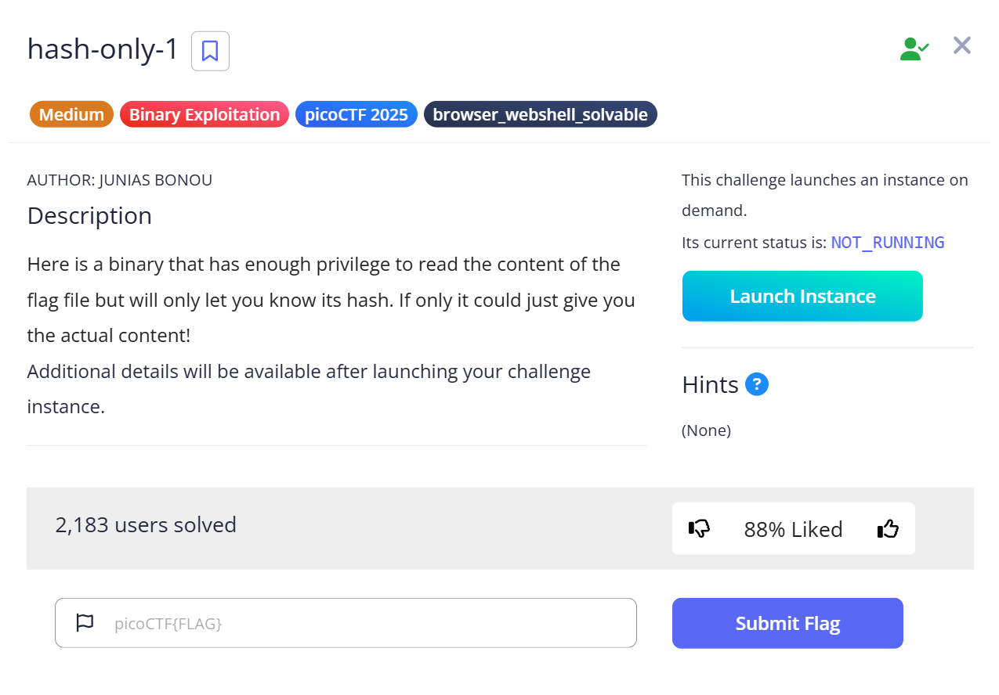

Figure 22 - Hash-only-1 Challenge

We can use the hash-only-1 we did before as a reference for this challenge to find the hidden flag more easily of this challenge.

## 2.2.1 Accessing the Challenge via ssh

By using the webshell that provided by the picoCTFplatform which is like a kali linux system.



Figure 23 – Access picoCTF Webshell

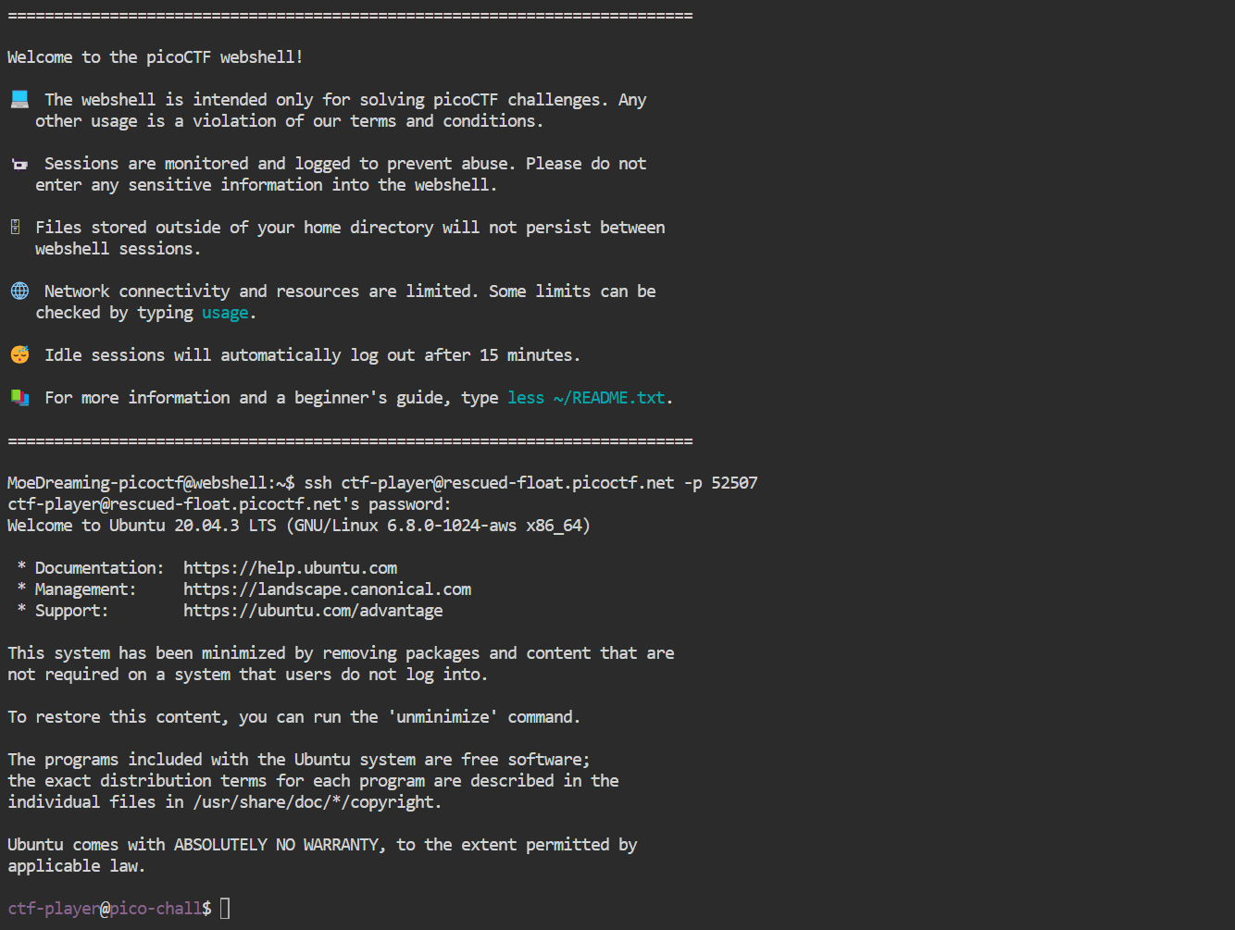

Figure 24 - picoCTF Webshell

Use the picoCTF webshell to connect to the challenge and typed ssh verbal-sleep.picoctf.net 52507 to see the content of the challenge. And right here we can start our CTF challenge to try to figure out where is the flaghasher locate.

# 3. Step-by-step Solutions

## 3.1 Guess My Cheese (Part 2)

### 3.1.1 Download the files

Downloading the cheese list.txt file from the challenge shows that the contents are all the names of various cheeses.



Figure 25 - cheese_list.txt

### 3.1.2 Analysis the files

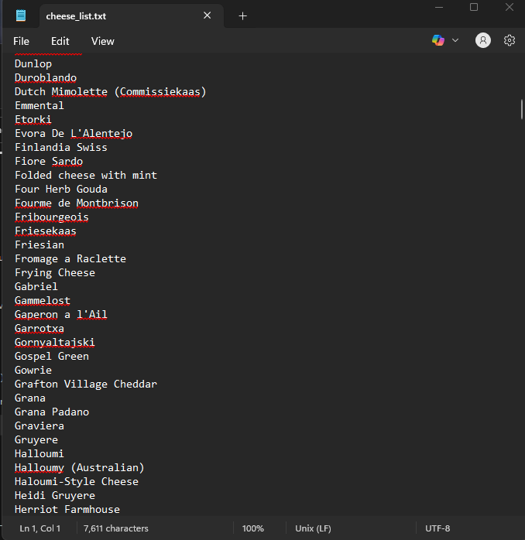

Figure 26 - cheese_list.txt

Looking at the cheese list, we can see that the cheese names are not consistent. Some names have uppercase and lowercase letters and even brackets. This inconsistency means that these cheese names can be represented as bytes in different ways, such as UTF-8, UTF-16 little endian and big endian, and Latin-1. Of course, we will also check this file to see if there are any suspicious flags, but unfortunately there are none.

### 3.1.3 Analysis the hash value

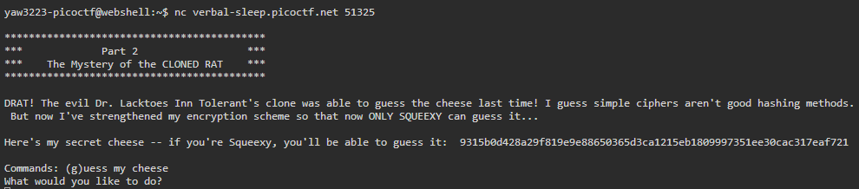

Figure 27 - Guess my Cheese (Part 2) Description

The challenge gives us a hash value. By judging that the hash value is 64 characters long, using hexadecimal characters we can be pretty sure that it is a sha256 hash. Hint 1 also mentions sha-256. We know that sha256 is a one-way encryption that cannot be reversed to retrieve the original text.

Hint 2 mentioned that the cheese name also has 2 hexadecimal characters, which means that the cheese name is mixed with 2 hexadecimal characters. This means that using brute force attack the cheese list file's all combinations cheese name method does not work. Our team was confused for a long time at this stage because we didn't understand what it really meant.

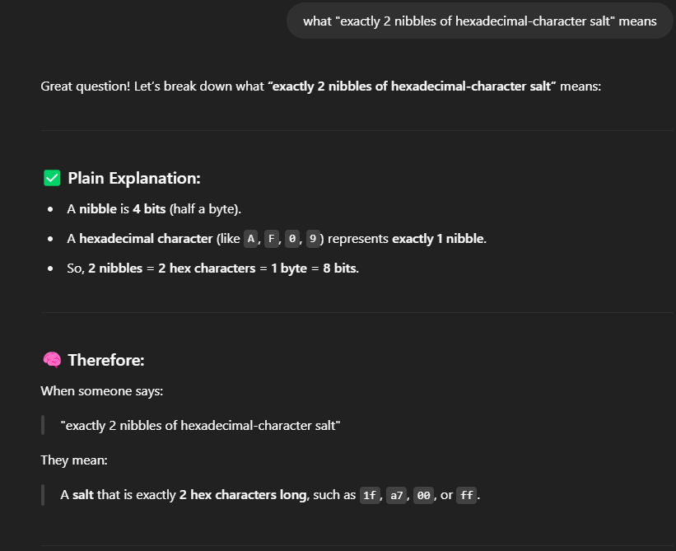

Figure 28 - Asking ChatGPT what salt means

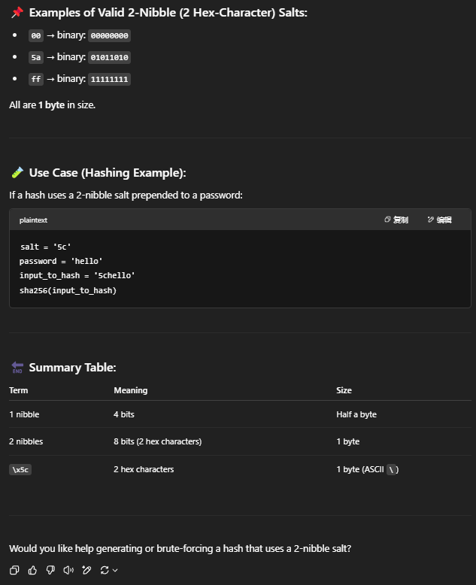

Figure 29 - ChatGPT Prompt

We used ChatGPT to understand that it was in the hexadecimal format of '\x5c', which brought us one step closer to getting the flag.

### 3.1.4 Determine the solution idea

After our team knew the format of the salt, we started brainstorming and decided that writing a python script would be the most feasible approach. The goal of this script is to pair each cheese name with a salt. Each cheese variant is paired with a salt value between 0 and 255. However, we don't know where the salt will be in the cheese name so there are three ways to add it: append, prepend or insert. This creates many potential combinations and calculates the sha256 value of each combination and then matches it with the sha256 value given by the challenge. If they are the same, it means the correct combination has been found.

Our team is responsible for their respective tasks:

* **Yaw Kai Yuan** focus on the concept of writing the entire code and ensure the logic is correct. Also optimize the code to make it clear and easy to understand.
* **Er Chen Liang** focus on debugging to see if the function and for loop are working successfully.
* **Chong Wai Kit**, **Huang Xiao Shun** focus on the final test results and test the hash value obtained from the challenge.

### 3.1.5 Python Script Implementation

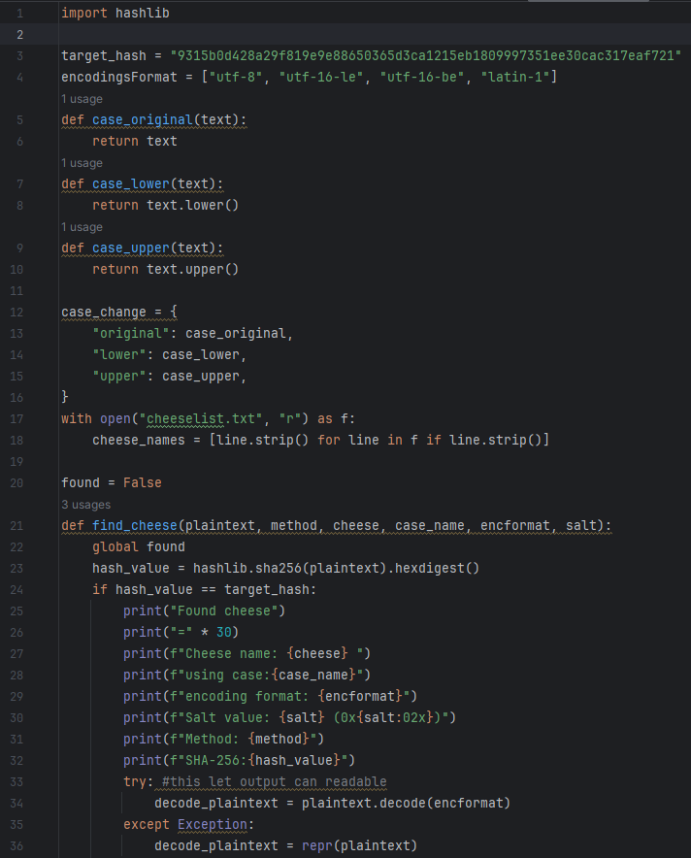

Figure 30 - Python Script

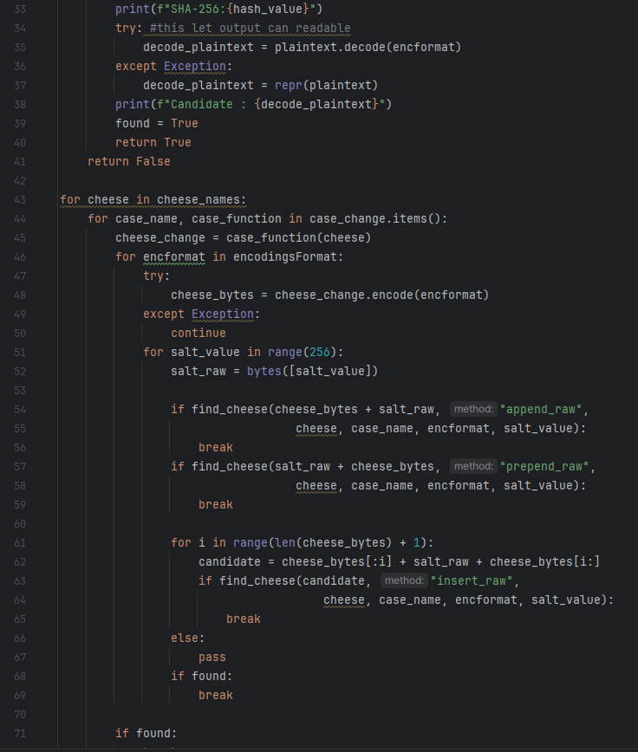

Figure 31 - Python Script

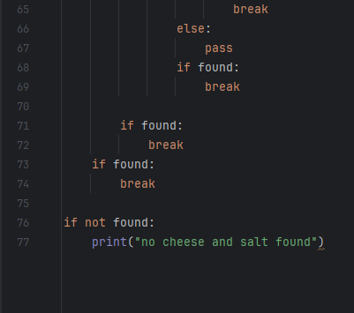

Figure 32 - Python Script

**Explanation**:

**Step 1: Variable**

* **target_hash:** This is the hash we got from the challenge. The goal is to crack it.
* **encodingsFormat:** Here is a list of common text encodings. Using different encodings can help us find more possibilities.
* **case_change:** This is a dictionary mapping uppercase and lowercase names to functions that change the case of the cheese name.

**Step 2: Function**

* **case_original, case_lower, case_upper Function**: These functions are responsible for changing the case of each cheese name. For example, original is the original name, lower is converted to lowercase, and upper is converted to uppercase. They are stored in the dictionary.
* **find_cheese Function:** This function takes a byte string of the cheese+salt combination and checks if it matches the target SHA-256 hash. If a match is found it will print out cheese name, encoding used, case variant, method used, and salt. It will then try to decode the bytes into readable words using .decode() and set found = True to exit the loop. If no match is found the loop will continue.

**Step 3: For loop**

* **for cheese in cheese_names**: This loops through all cheese names from the file.
* **for case_name, case_function in case_change.items()**: Tries each case format such as original, lowercase, uppercase.
* **cheese_change = case_function(cheese):** Applies the case_function to the cheese name.
* **for encformat in encodingsFormat**: Try every encoding type such as utf-8, utf-16-le, utf-16-be, latin-1.
* **cheese_bytes = cheese_change.encode(encformat):** Convert the cheese string using the current encoding.
* **for salt_value in range(256):** Tries every possible salt value from 0x00 to 0xFF.
* **salt_raw = bytes([salt_value])**: This converts the salt value into raw format.

**Three methods to combine cheese and salt**

* **cheese_bytes + salt_raw:** This is append salt to the end of the cheese.
* **salt_raw + cheese_bytes:** This is prepend salt to the beginning.
* **cheese_bytes[:i] + salt_raw + cheese_bytes[i:]:** This is insert salt at every possible position.

After each method it call find_cheese function

**Step 4: Output**

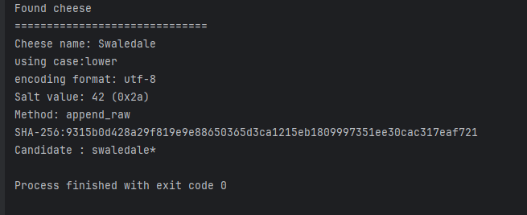

Figure 33 - Python Script Output

After running the code, we can see that the sha256 hash value has been cracked. The picture shows what method is used to decode it.

### 3.1.6 Guess the Cheese

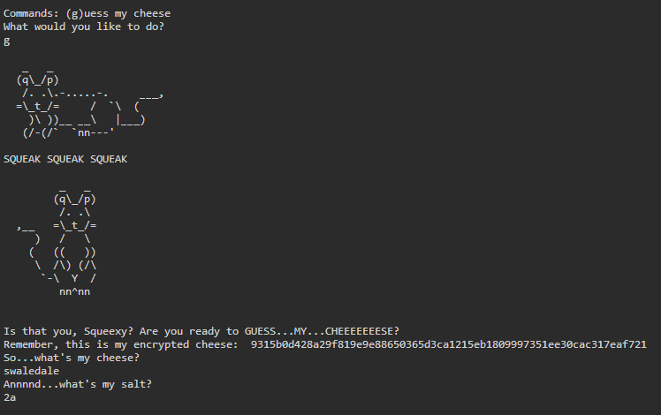

Figure 34 - Enter Answer in Webshell

Enter the cheese name and salt value you just got from the Python script.

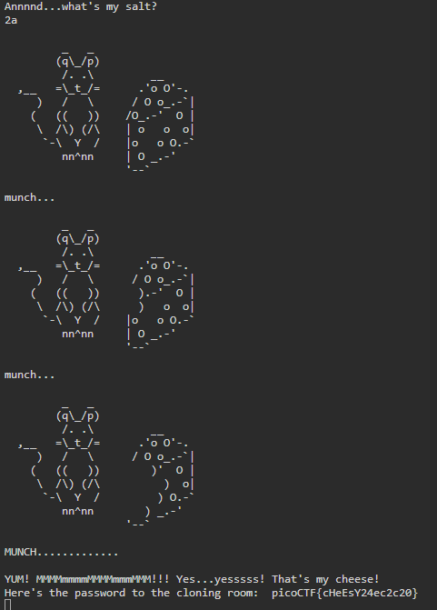

Figure 35 - Capture the Flag

Yes, we finally got the flag!!! picoCTF{cHeEsY24ec2c20}

### 3.1.7 Submit the Flag

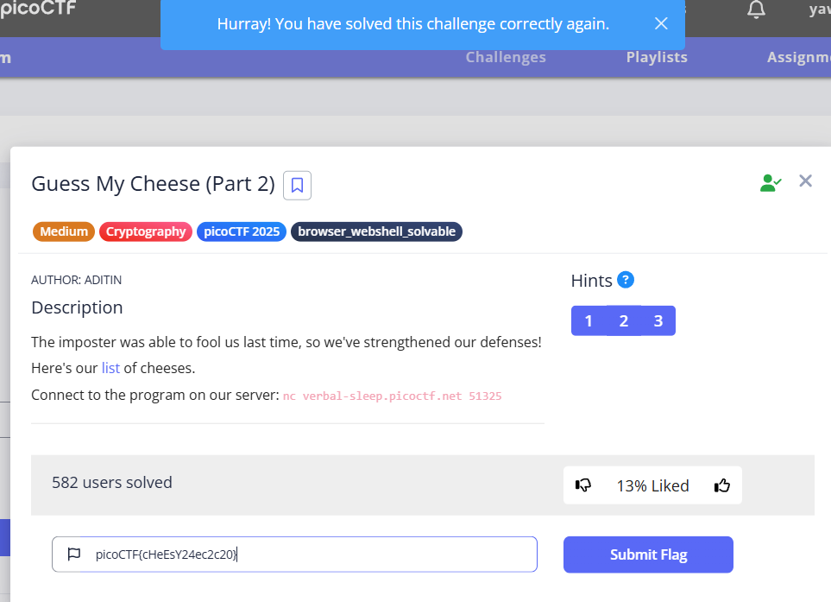

Figure 36 - Submit the Flag

We successfully submitted the flag to represent the solution of this challenge.

**Flag**:

picoCTF{cHeEsY24ec2c20}

## 3.2 Hash-only-2

### 3.2.1 Launch the challenge

To start the challenge, we need to launch the challenge at the picoCTF to get the ssh command and the password which can allow us to start our investigating on the web shell.

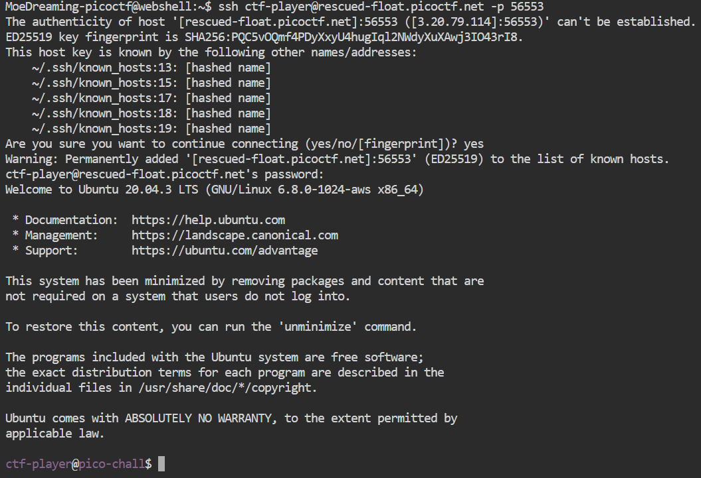

Figure 37 - Access hash-only-2 in webshell

### 3.2.2 Locate the flaghasher

As we need to run the binary name of the “flaghasher” we must first locate the path of it in the system. The most common way to find the file is using the ls command.

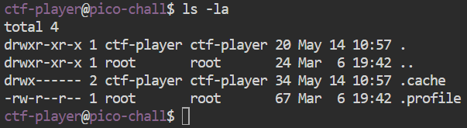

Figure 38 - Locate the flaghasher

We use the ls –la command to list all the files including hidden files. And we can see that the current directory does not show any of file or binary named “flaghasher”. So, we try another way to find where is the “flaghasher” located.

### 3.2.3 Determine the solution idea

We know that although we cannot get the location of “flaghasher” directly through the ls -la command, but it must exist in this system. So, we must think of some way to find it to proceed to the next step.



Figure 39 - Find the flaghasher

Our team is responsible for their respective tasks:

* **Yaw Kai Yuan** focused on writing and reviewing the logic of all the supporting code required to interact with the binary.
* **Er Chen Liang** focused on debugging. He verified that all commands worked as expected, especially when testing the input to the flaghasher.
* **Chong Wai Kit** and **Huang Xiao Shun** focused on final testing. They run the flaghasher, analyzed its output, get the hashes, and replaced the hashes to get the flags.

### 3.2.4 Implementation of various codes

Next, we use the which command and whereis command which provide by ChatGPT to work around this limitation: As we can see we successfully get the path of the flaghasher which was located at /usr/local/bin/flaghasher.

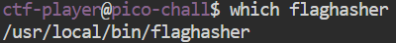

Figure 40 - Which is the flaghasher directory

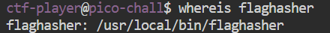

Figure 41 - Where is the flaghasher directory

And now we can just simply execute it by typing “flaghasher”.

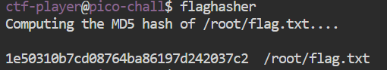

Figure 42 - Execute flaghasher

**Explanation of codes**:

* **find**: search for corresponding files or directories.
* **2>/dev/null**: hide the error messages from commands.
* **which**: a command which can show the path.
* **whereis**: a command which can locates binary, source, and man pages.
* **cd**: change directory.

### 3.2.5 Bypassing Restrictions and Hijacking the MD5sum

When we get the MD5 ash of the flaghasher, we can attempt the similar step of the hash-only-1 that we did which can replace the MD5 hash of the flaghasher. So, we replace the md5sum with a fake script that just prints the contents of /root/flag.txt with this code **‘echo "/bin/cat /root/flag.txt" | tee ~/md5sum’**.



Figure 43 - Replace MD5 hash

Then, we make it become executable by using **chmod + x**.

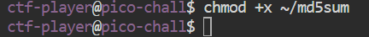

Figure 44 - Change file permission

We found out that we still couldn't run it even if we replaced it into the /bin/cat /root/flag.txt, so we tried another method which was to start a clean bash to escape the limitations of rbash **‘env /bin/bash’**.

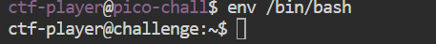

Figure 45 – Escape the limitations of rbash

Next, we ask ChatGPT to modify the PATH so that our custom md5sum located in /home/ctf-player/ would be executed **before** the system's real md5sum:

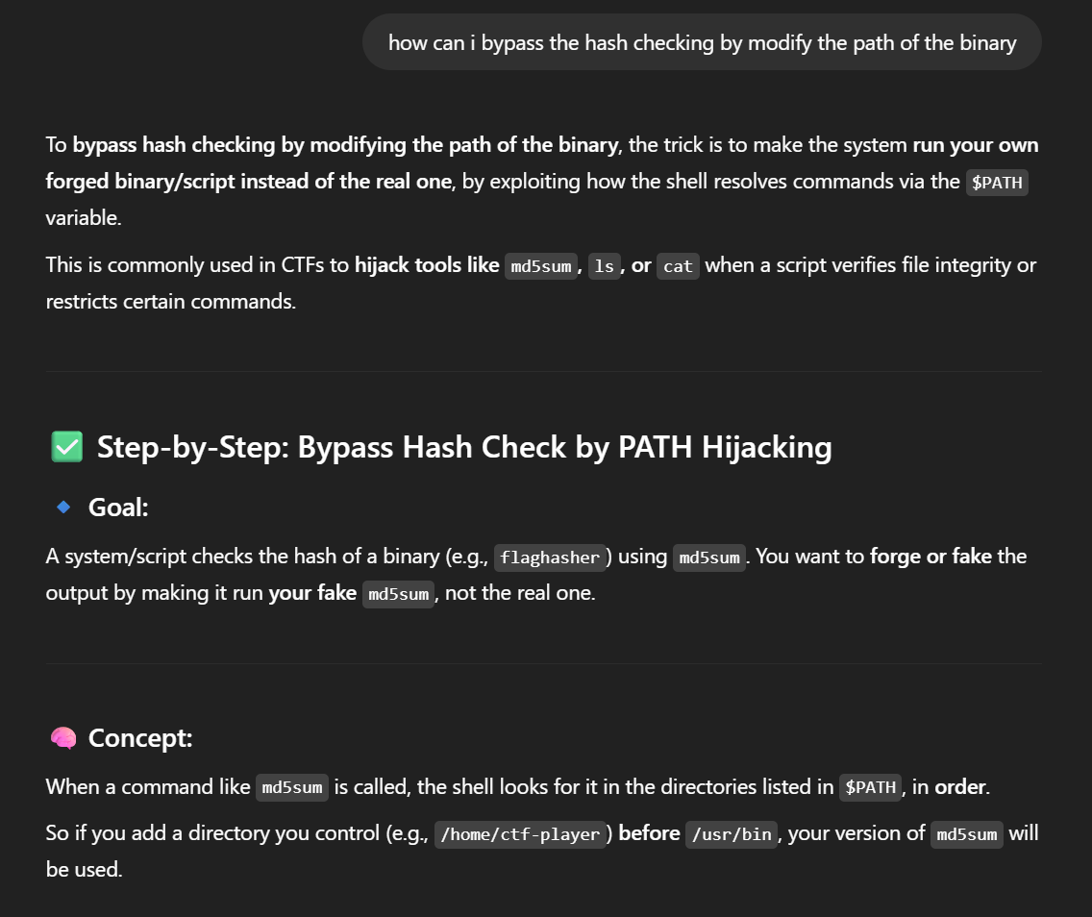

Figure 46 - Asking ChatGPT how to bypass

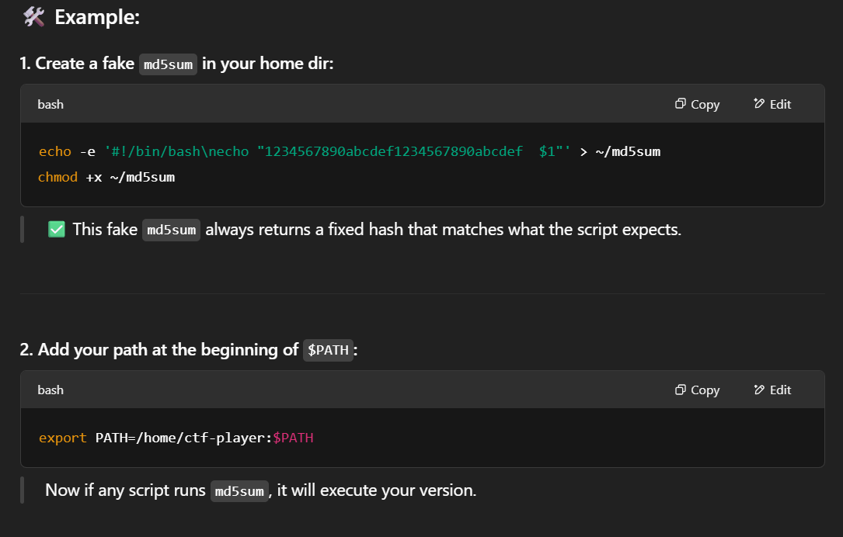

Figure 47 - ChatGPT Prompt



Figure 48 - Look for /home/ctf-player path

This command can ensure that when the system looks for an executable such as md5sum, it will check for the custom script in /home/ctf-player first, which the flaghasher is located also.

And after we executed the flaghasher, the flag had appeared right there!! picoCTF{Co-@utH0r_Of_Sy5tem_b!n@riEs_797957c8}

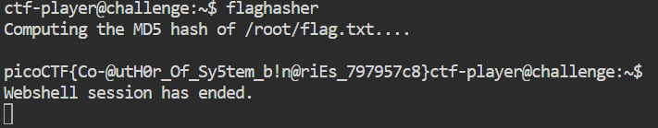

Figure 49 - Capture the Flag

### 3.2.6 Submit the Flag

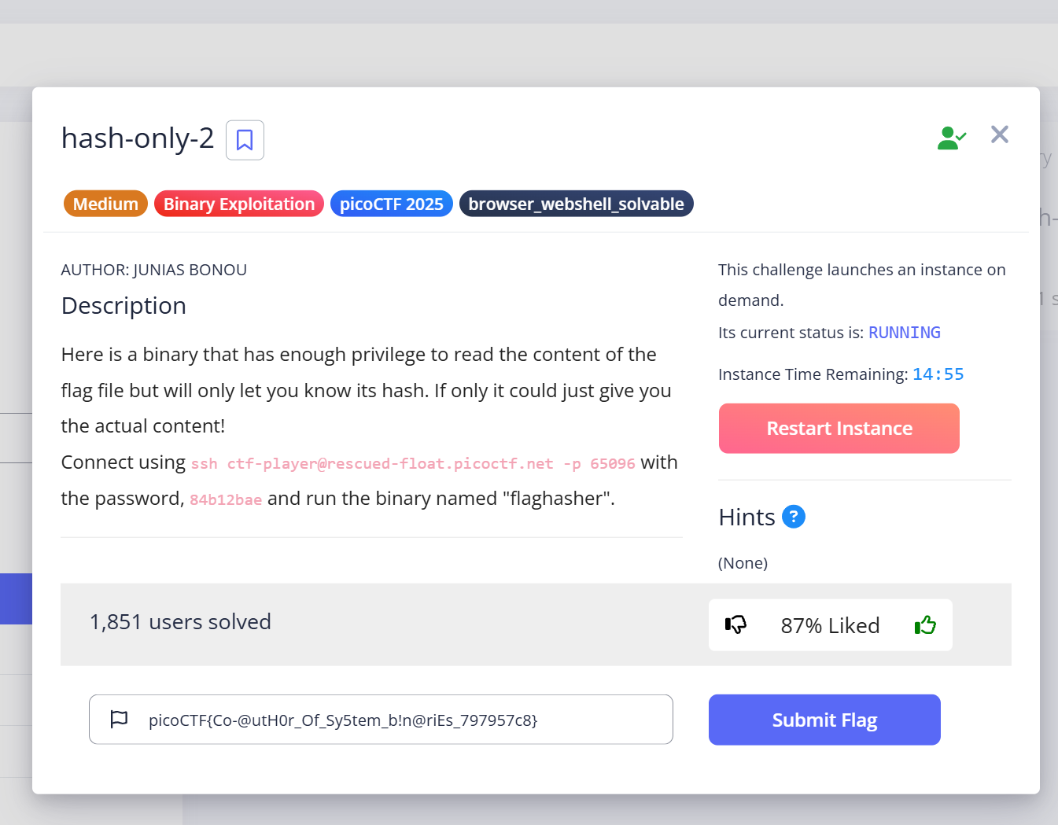

Figure 50 - Submit the Hash-only-2 Flag

We submitted the flag successfully to represent the solution of this challenge.

**Flag**:

picoCTF{Co-@utH0r_Of_Sy5tem_b!n@riEs_797957c8}

# 4. Tools, Command and Script Used

## 4.1 Webshell



Figure 51 - Webshell

Webshell is an online terminal emulator that can run a real Linux shell in the browser (Cobb, 2016). Things we can do in webshell include editing code with nano, vim, running python scripts, connecting to remote servers with nc, and downloading tools with wget or curl. We used this tool to connect to the guess my cheese (part 2) challenge without downloading anything. It's very lightweight.

The following table is a comparison between webshell and SSH terminal. It shows why we choose webshell.

|  |  |  |
| --- | --- | --- |
| **Feature** | **Webshell** | **SSH Terminal** |
| **Browser-Based** | Yes | No |
| **CTF-Specific** | Designed for challenges | No |
| **Needs installation** | None | Yes (SSH Client) |
| **Security sandboxed** | Isolated per challenge | Depends on server |

**Reason**: We chose webshell because it is browser-based and designed specifically for CTF challenges.

## 4.2 Netcat

Netcat often called nc is a powerful command line network tool that uses TCP and UDP connections to read and write operations on the network. It can also be used for attack or protection and is applicable to all operating systems (GeeksforGeeks, 2023). Netcat is a key command in this challenge that allows us to connect to the server. It is fast, minimal and doesn’t require setup.

In CTF, netcat can communicate interactively, such as in interactive reverse engineering and brute force cracking. It can also be used as a data pipeline to transfer the input or output of scripts or files to netcat. In addition, it has good compatibility and can run automated attacks and responses with scripts such as python and bash. The following table is a comparison between netcat and telnet.

|  |  |  |
| --- | --- | --- |
| **Feature** | **Netcat** | **Telnet** |
| **Purpose** | Raw TCP/UDP data sender/receiver | Terminal-based TCP client |
| **Protocol Support** | TCP, UDP | TCP only |
| **Interactivity** | Raw input and output, flexible | Interactive terminal-like session |
| **Scripting/Automation** | Easily scriptable with pipes or input files | Hard to automate without expect |
| **Use in CTFs** | Preferred for flexibility and raw contro | Usable, but limited functionality |
| **Data Control** | Full control over line endings, binary data | Limited, interprets control characters |

**Reason**: We chose netcat to connect to the server because it sends and receives data as is while Telnet adds extra characters.

## 4.3 ChatGPT



Figure 52 – ChatGPT (Hetler, 2025)

ChatGPT is an AI chatbot developed by OpenAI, which is built on a large language model of GPT, which stands for Generative Pre-trained Transformer (Hetler, 2025). Its goal is to understand natural language input and be able to have conversations with humans, answer questions, assist in writing code, write content, and more. It will also be trained with data sets from the Internet, books, and other sources to become more intelligent. In addition, ChatGPT will process the user's input to predict the next word to generate a coherent response based on the results.



Figure 53 - ChatGPT Prompt

When we first tried this challenge, we were asked to enter a salt value but we had no idea what a salt value was so we asked ChatGPT to explain it to us. The following is an explanation of chatgpt：

**A nibble is 4 bits**: A nibble consists of 4 bits. It can represent 16 different values, ranging from 0000 to 1111 in binary.

**A hexadecimal character represents exactly 1 nibble**: Hexadecimal is a base 16 number system that uses the digits 0-9 and the letters A-F (representing values ​​10-15) to represent numbers. Each hexadecimal digit corresponds to a 4-bit binary value.

So, to sum up 2 nibbles = 2 hex characters = 1 byte = 8 bits.

The following table is a comparison between ChatGPT and Gemini (Jayaraman, 2025).

|  |  |  |
| --- | --- | --- |
| **Feature** | **ChatGPT** | **Gemini** |
| **Code Assistance** | Excellent | Good |
| **Writing Skills** | Natural, creative, high flexible | Informative, structured |
| **Reasoning Ability** | Very Strong (GPT-4 Turbo) | Moderate to Strong (Gemini 1.5) |
| **Memory** | Experimental (user-controlled) | No |
| **Best For** | General use, coding, CTF | Research, summaries, web data |

**Reason**: The reason for choosing ChatGPT is that the model is more powerful (GPT-4 Turbo), can handle CTF questions intelligently.

## 4.4 Python Programming Language



Figure 54 – Python (W3Schools, n.d.)

Python is a high-level programming language with a syntax similar to English and known for its simplicity, readability, and versatility (W3Schools, n.d.). It is used in a wide range of fields such as web development, data science, artificial intelligence, machine learning, automation, network security, etc. This makes Python one of the most widely used programming languages ​​in the world.



Figure 55 - Python Script

We use Python to write a script to brute force every combination of cheese name and salt value.

The following table is a comparison between Python and Java (Kareliya, 2024).

|  |  |  |
| --- | --- | --- |
| **Feature** | **Python** | **Java** |
| Syntax | Simple, readable | Verbose, but structured |
| Ease of Learning | Very Easy | Medium |
| Community Support | Excellent | Large |
| Use Cases | Web, AI, Data, Scripting | Enterprise apps, Android |

**Reason**: We use Python because its syntax is simple, and it is easy to write scripts without spending a lot of time.

## 4.5 PyCharm



Figure 56 – PyCharm (GeeksforGeeks, 2023)

PyCharm is a professional IDE developed by JetBrains, which means that the integrated development environment is designed for Python development (GeeksforGeeks, 2023). It provides a complete set of tools to write, debug and manage Python code more efficiently. When we write Python scripts in Pycharm, it can highlight syntax and errors, making it much easier for us. Finally, we run the completed script in PyCharm to get the cheese name and salt value of the challenge. The following is a comparison between PyCharm and Jupiter notebook (Garkusha, 2024).

|  |  |  |
| --- | --- | --- |
| **Feature** | **Pycharm** | **Jupiter Notebook** |
| **Type** | Full IDE | Interactive Notebook Environment |
| **Code Completion** | Excellent | Basic |
| **Debugger** | Powerful | Limited |
| **Best For** | Professional Python Development | Data Science, Machine Learning, Visualization |
| **Integrated Terminal** | Yes | No |
| **Virtual Environment Support** | Excellent | No |

**Reason**: We use PyCharm because it is suitable for the python environment and we have previous experience using it.

## 4.6 Secure Shell (SSH)

Secure Shell often called ssh is a secure protocol that allows encrypted communication between systems (Gillis, 2024). It protects our data from eavesdropping. In the hash-only-2 we used the ssh command to connect to the challenge so that we can connect to the CTF challenge environment provided by picoCTF on our own device.

Example command in this challenge:

ssh ctf-player@rescued-float.picoctf.net -p 60922

The reason why ssh is used in the hash-only-2 challenge is that the design of this challenge requires interaction with the system and the permission to log in remotely to the Linux computer with the username and password is granted.

## 4.7 PATH Hijacking and Command Substitution

Hijacking PATH is a practise that exploits the system’s order for executing commands. If the directory where the user has written access comes before the actual command’s directory in the $PATH, they can place a script with the same name as a usual command (e.g., md5sum) in it. When the command is to be executed, the system mistakably runs the fake version instead of the correct one.

We used this method to take over the md5sum command in the hash-only-2 challenge. Rather than using the original md5sum tool, we made a fake one that would simply show the contents of **/root/flag.txt** tostoring the flag.

## 4.8 env Command

The env command is normally used to create or alter environment variables and to run commands in a different setting (GeeksforGeeks, 2024). In this case, it is meant to get around a restricted shell (rbash).

With restricted shells, a user is not allowed to access certain commands or paths. You can try to escape by running a new shell that is not restricted using:



Figure 57 - Example Using env commands

As soon as you log in, you’ll get access to a regular bash session, which lets you bypass the restrictions and control everything in the environment.

By using this trick, we could run commands in rbash that we could not run before.

# 5. Vulnerabilities and Exploitations of the Challenge

## 5.1 Guess My Cheese (Part 2)

The vulnerability and exploit for this challenge is to brute force weak input. The main vulnerability is that the hash of cheese is from a list of known names, a byte of salt with 256 possibilities and basic permutations like case. In fact, the input space is very small and if there are only these conditions, we can quickly try various combinations to crack.

Next, this challenge system has a hash identification vulnerability, which is a fatal flaw because the system only identifies by comparing hash values ​​without timeouts, rate limits, or key stretching methods to constrain users. Once an attacker obtains the hash value, they can brute force millions of combinations offline.

## 5.2 hash-only-2

The vulnerability in the hash-only-2 challenges lies in an insecure environment configuration. While our access was getting limited to the flag by only displaying its MD5 hash when running flaghasher, it did not properly protect or validate the challenge environment. So, it is an opportunity for us to use the PATH hijacking to complete this challenge.

Next, the system has been configured to use a restricted shell to limit our actions. However, this restriction is flawed as we can bypass this unrestricted system code by running env /bin/bash. This vulnerability defeats all commands and environment restrictions set by the restricted shell which allow us to perform the MD5sum substitution and run it in that environment to get the final flag.

# 6. Knowledge and Skills Learned

At the beginning while doing these two challenges we knew little about cryptography and binary leaks as beginner. However, we worked hard to crack these two challenges and solved them successfully and our efforts were not in vain. During the process we learnt how sha-256 works and Linux command skills and deepened our understanding of these two areas.

In the guess my cheese (part 2) challenge, we researched various ways to crack sha256 and ended up writing scripts using python. For example, the process of writing scripts helped us understand how sha256 hashes work and why reversing hashing algorithms requires brute force cracking and strengthened our scripting skills. We also gained practical experience using different text encodings such as UTF-8, UTF-16, Latin-1, and string case. We understood that adding a byte would increase the complexity of the hash. From the beginning when we saw the sha256 hash value as an unreadable text that could not be cracked, we now think critically about how it works and how to reverse it. This is our growth in this challenge.

Next, in the hash-only-2 challenge, we kept researching what command to use to find the flaghasher binary. We found that Linux has a find command that can easily find it, but a new problem arose, access was restricted by the shell (rbash). We generated a new shell to bypass the restricted environment and hijack the command using $PATH to make the system run a fake version. This allowed us to understand the command execution order in the Unix system, shell navigation and utilization, and environment variable manipulation to enhance our skills in using Linux commands.

# 7. Challenges Faced

These two challenges seem to be easy to solve, but they are not. The challenges were solved by our team discussing, communicating, and sharing ideas, and we got closer and closer to the answer. We encountered many difficulties in the process of doing the challenges, which hindered our progress. For example, we conducted these two challenges on the webshell platform, but during the process of researching the challenges, the webshell suddenly reset or the instance of the hash-only-2 challenge reset, and we encountered the limitations of these platforms. Because of this difficulty, an invisible pressure was formed, which kept pushing us to work hard to come up with a solution.

## 7.1 Guess My Cheese (Part 2)

### 7.1.1 Using online hash cracker tools

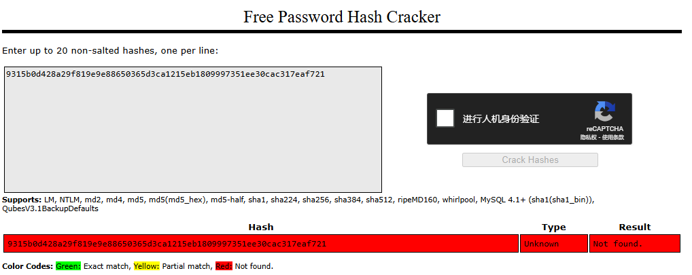

Figure 58 - Online Hash Cracker Tool (CrackStation, n.d.)

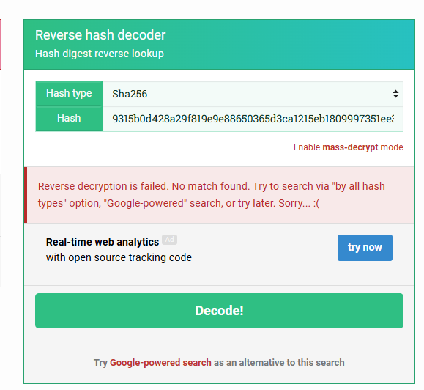

Figure 59 - Online Reverse Hash Tool (MD5Hashing, n.d.)

**Problem**: These online hash cracker tools are rainbow tables. The principle is to use pre-computed input-hash mapping tables. But the hash value of this challenge is salted, so this method does not work.

**Solution**: The way to solve this problem is to write a script to combine various possibilities to pair hash values. Then choose Python as the programming language because Python's syntax is clear and intuitive.

### 7.1.2 Hashcat not working

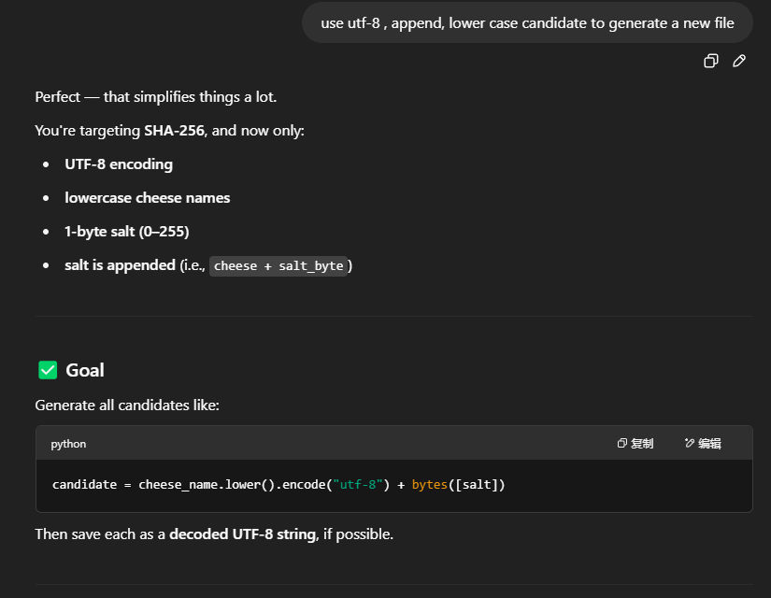

Figure 60 - Asking ChatGPT Generate Script

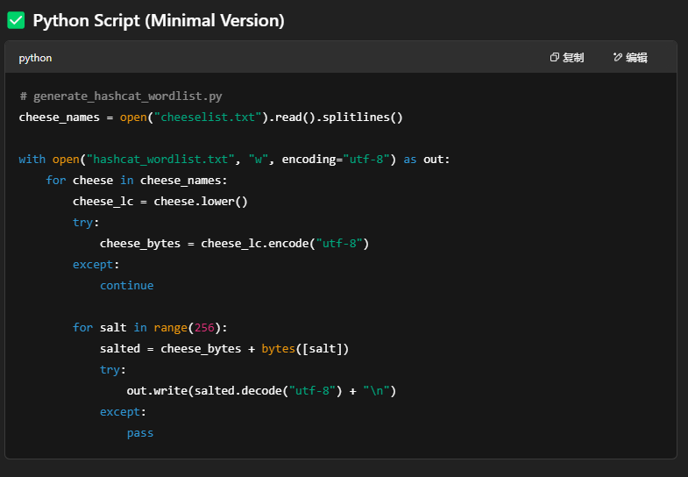

Figure 61 - ChatGPT Prompt

Ask ChatGPT to generate a script with the salt value added to the cheese name and writes it to a text file.

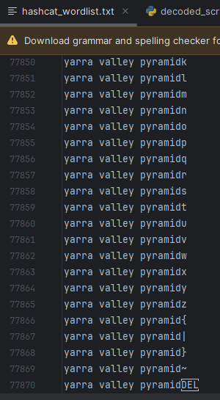

Figure 62 – Script Output

This is the text file generated after executing the code. It has more than 70,000 lines. Then put the file into the kali linux.



Figure 63 - Using Hash cat commands

Hashcat is a dictionary attack method that compares the target hash value with the input hash value. Since we provide the hash value file, this method should work. Its advantage is that it is very fast and supports many hash types and various attack modes.

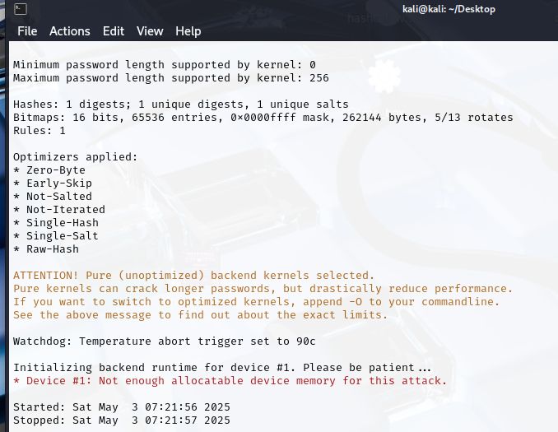

Figure 64 - Failed to Start Brute Force

**Problems**: Our team used hashcat to brute force the sha256 hash value, but during the run, the error **Device #1: Not enough allocatable device memory for this attack** popped up. This error means that the GPU does not have enough memory to run the attack even though our team all use gaming laptops.

**Solution:** After trying rainbow attack and dictionary attack, both failed. The last resort was to write a custom script to brute force.

### 7.1.3 Misunderstanding the meaning of salt

When we first wrote the script, we misunderstood the meaning of salt value, which resulted in the script not being able to find the cheese for the challenge. We consider the salt value to be 00 to ff instead of hexadecimal escapes of backslashes.

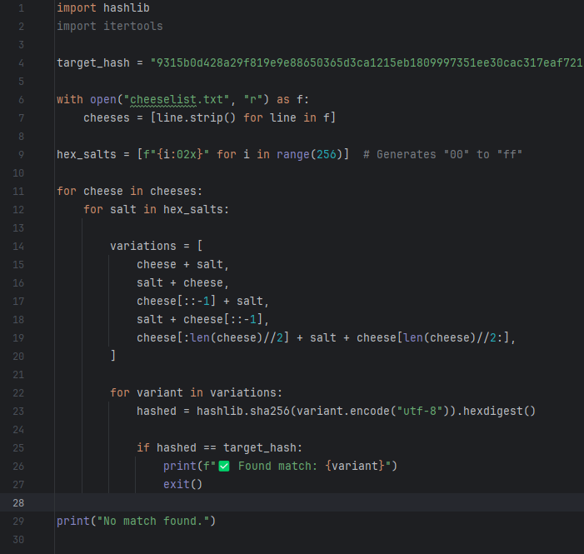

Figure 65 - Wrong Python Script

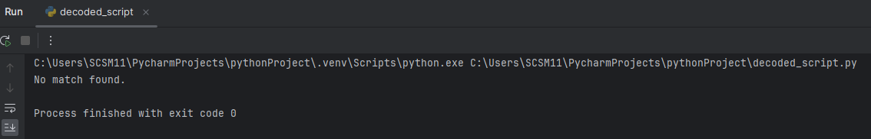

Figure 66 - Output

We discovered this problem because we took one of the cheese names in the file and added a random salt value from 00 to ff to convert it to the sha256 hash value and then used this script to crack it. Surprisingly, this script cracked it.

This is the cheese name converted to sha256 hash with wrong salt added: ca97460b9d610688aa1405eadd4f85150ba83cc867cafee9c40d99dac0bff083

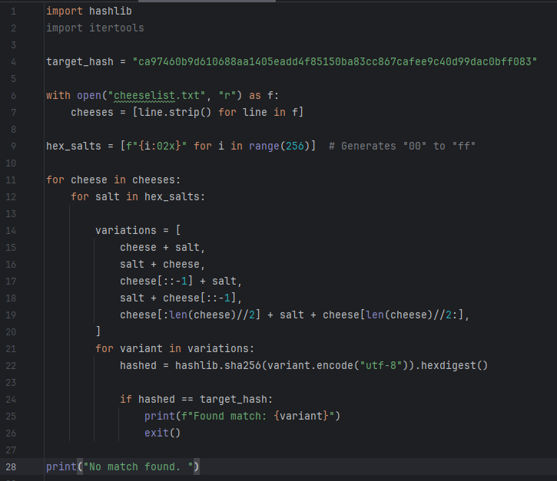

Figure 67 - Try to crack our generated hash



Figure 68 - Output

**Solution**: We judged that the script could not crack the hash value given to us by the challenge, which meant that we misunderstood the meaning of the salt value, so we used ChatGPT to understand it again.



Figure 69 - ChatGPT Prompt

## 7.2 Hash-only-2

### 7.2.1 Difficulty Locating the Binary of flaghasher

When we are using the ls –la command, we still could not see where is the binary flaghasher was located.



Figure 70 - Try to find the flaghasher

To solve this problem, we use ChatGPT to generate some command which can try to locate the binary. And of course, we use which command and whereis command to successfully found the location of flaghasher but also there is another problem that follows.

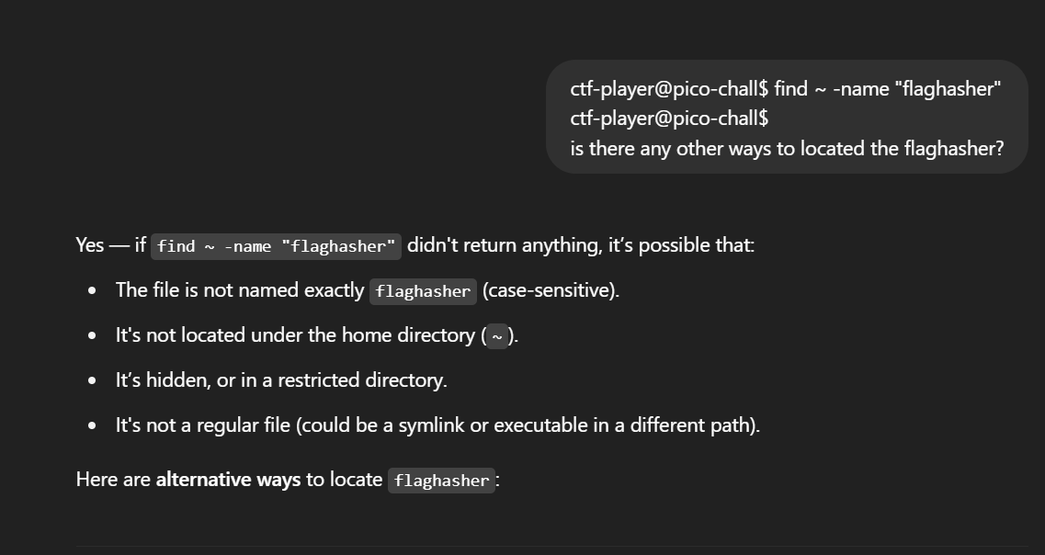

Figure 71 - Asking ChatGPT for idea

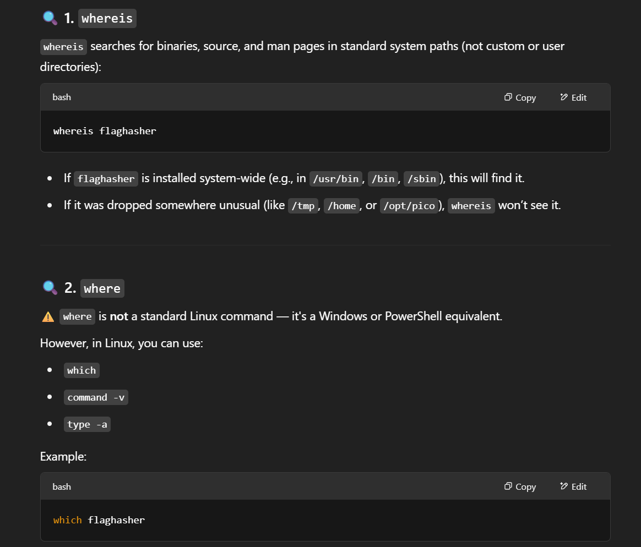

Figure 72 - ChatGPT Prompt

### 7.2.2 Misunderstanding of the Access Permission

After we located the flaghasher is in the path of (/usr/local/bin/flaghasher), our team attempted to change the directory into it by using the cd command. But when we attempt the cd command it shows the followings errors.



Figure 73 - Restricted by rbash

We were a bit confused about this, but with the help of ChatGPT. We know that we can just simply type the flaghasher in the webshell to run the binary.

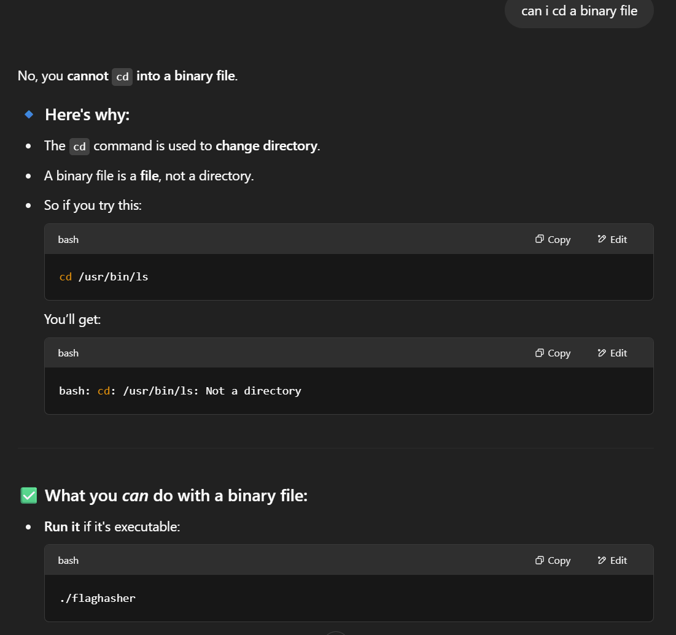

Figure 74 – Confused and Asked ChatGPT

### 7.2.3 Overcoming the rbash restriction

When we are trying to display the flag which is inside the /root/flag.txt unfortunately an error occurs. The system shows that we are restricted and we are overwhelmed.



Figure 75 - Restricted by rbash

Our team cleverly bypassed it by asking ChatGPT the ways to launch a new unrestricted shell by using the **env /bash/bin** command.

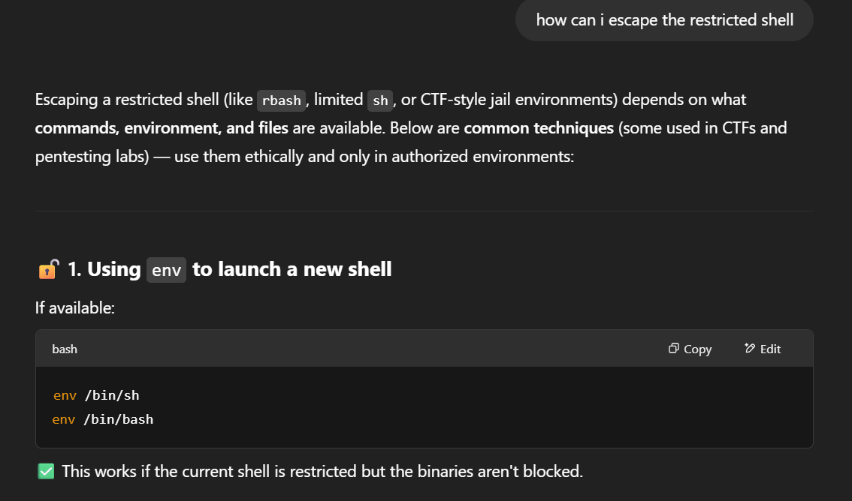

Figure 76 - Asking ChatGPT how to bypass

Which is a known method for escaping restricted shells.



Figure 77 - Bypass Command

After we successfully escaped the restricted shell environment, we were able to perform all the necessary actions without encountering any further problems.

# 8. Lesson Learned

Here are the lessons we learned from this CTF competition:

**Team Collaboration and Communication Skills**: We learned from this competition that teamwork is very important. Everyone plays to his or her strengths, which reduces the difficulty a lot. In addition, we need to clearly tell each other our ideas and make sure that the other party understands. This inadvertently exercises our communication skills. However, our team assigned tasks but did not have a common time to discuss the problem together, which made it impossible to communicate our ideas and we were stuck in the challenge for a long time. This also makes us realize that teamwork in the field of cybersecurity is crucial because it is needed to effectively solve complex problems.

**Analytical Thinking**: We need to think critically about how the challenge works and what the logic is and then crack it. For example, in the "Guess my cheese" challenge, how the hash value generation works and in the hash-only-2 challenge, we have to figure out how to bypass the system. In the field of cybersecurity, guessing will not solve the problem, structured reasoning is the key.

**Learning Under Pressure**: CTF competitions have time limits and provide limited hints for us to solve challenges, which is very similar to real-life events. We need to think quickly and learn new things immediately. Our team needs to come up with strategies and plans to solve challenges under time pressure, which trains our ability to think under pressure, learn new concepts quickly, and act decisively.

**Adaptability and Resilience**: During the competition, not every solution we tried worked, like the combination of cheese and salt, the command we entered failed, or the tool didn’t work on our computer. The frustration of not being able to find the answer forced us to adapt, troubleshoot, and keep trying to find new solutions. This fostered our perseverance, which is very valuable in the real world.

# 9. Summary – ELIF (Explain Like I’m Five)

## 9.1 The Secret Recipe

One day, our team was invited to a magical cooking show. We were asked to be the chef, and the judges gave us a secret dish - a special cheese dish locked with a password! We couldn't see the cheese, only a gibberish called a hash.

The host gave us the task of "to crack the recipe, we prepared cheese, salt, and a pan called SHA-256 and tried to make the secret dish.

We tried all the salt values ​​to add cheese such as append salt, prepend salt, and insert salt. But none of them matched the judges' password. So, we made a robot chef (written in Python script!) that could try all cheeses, all sizes, all sprinkles. It moved quickly, mixed the cheese and salt together, and fried the dish in a hash pan, over and over again.

After many cheese attempts. We found the perfect recipe! The hash matched successfully, the judges gave us the flag, and the audience cheered. We learned in this challenge that with smart robots (python script), good teamwork, and the right amount of salt, you can crack the password!

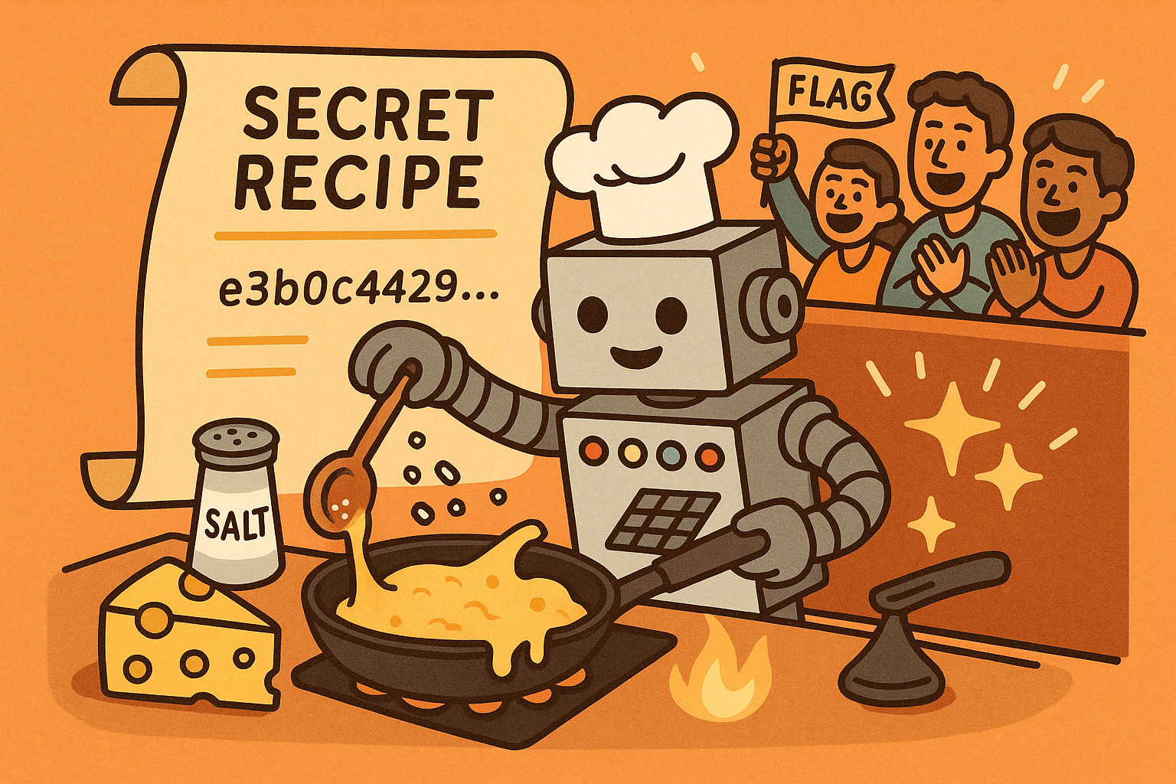

Figure 78 - The Secret Recipe

## 9.2 The Escape Room Trap

In the next adventure, we were locked in a trapped box called rbash. It was like a computer prison. We couldn't move around, couldn't use tools, and couldn't do anything in here. But we knew the treasure (the flag) was hidden somewhere, but we were trapped.

We looked around the trapped box and found a magic spell! It said: "env /bin/bash"

Then, as our team worked together to cast the spell, a door suddenly appeared in front of us, and we were free! Now we could explore.

We found a machine that needed help. It wanted to check something with a tool called md5sum. But guess what we did? We faked an md5sum and gave the answer we wanted: "Show us the flag! (PATH Hijacking)"

The computer obeyed our fake tool's instructions, gave us the flag and ran away. We learned that even if the system says "no", there is always a clever way to say "yes" with a little magic, a fake tool and good teamwork.

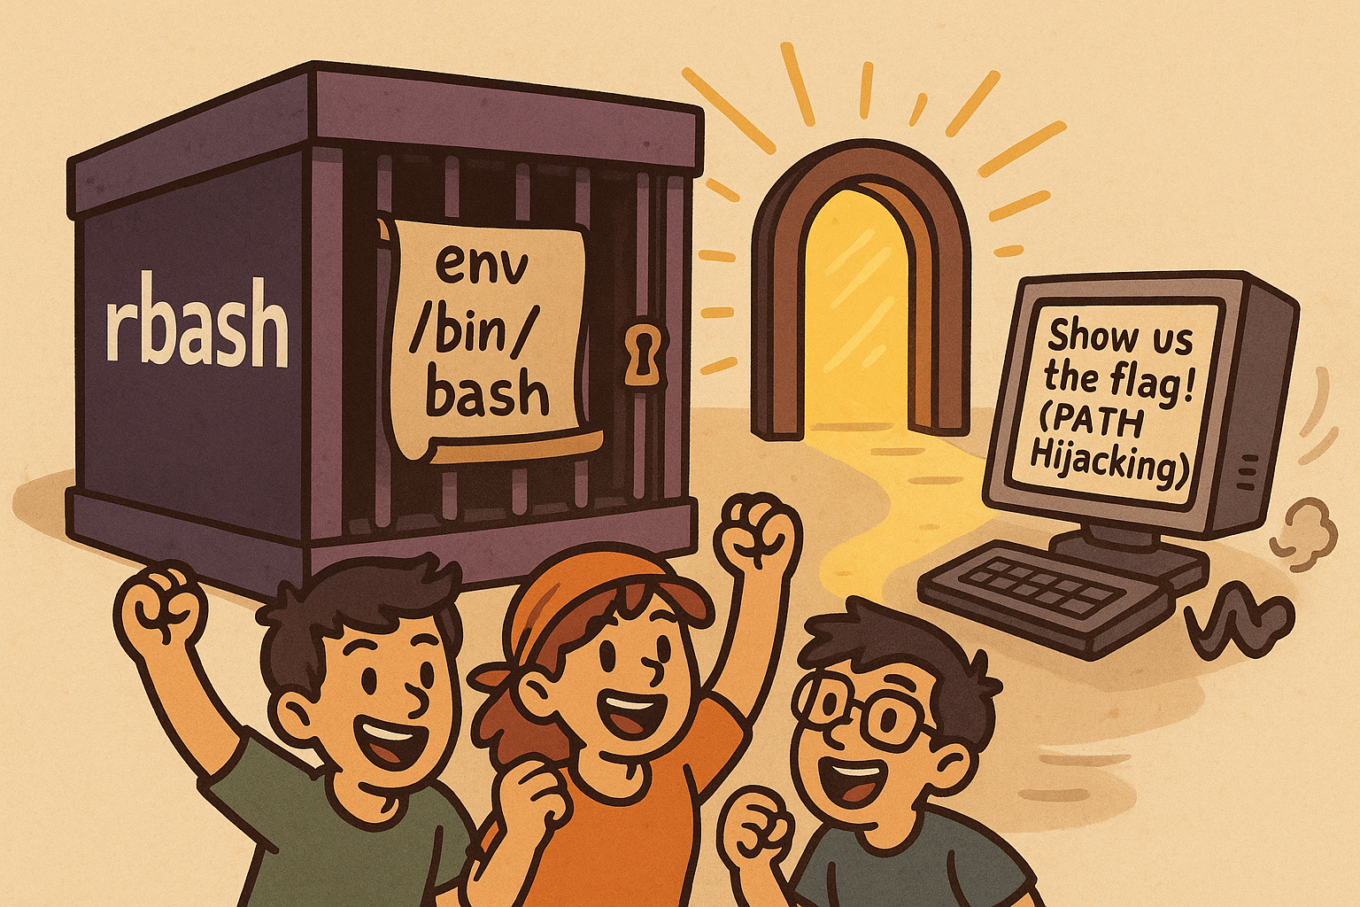

Figure 79 - The Escape Room Trap

# 10. Workload Matrix

|  |  |  |
| --- | --- | --- |
| **Team Member** | **Work Distribution** | **Workload Percentage** |
| Yaw Kai Yuan | - Test guess my cheese (part 2) multiple solution  - Writing the script and code  - Guess my cheese (part 2) writeup  - Documentation  - ELIF Idea | 30% |
| Er Chen Liang | - Test hash-only-2 multiple solution  - Debugging the script and code  - Hash-only-2 writeup | 30% |
| Chong Wai Kit | - Analyse tool using  - Assists solve the challenge 1 | 20% |
| Huang Xiao Shunn | - Try to find the challenge vulnerabilities  - Assists solve the challenge 2 | 20% |

# 11. References

Carnegie Mellon University. (2025). *picoCTF 2025*. <https://play.picoctf.org/events/74>

Cobb, M. (2016, August). *How can web shells be used to exploit security tools and servers?* SearchSecurity. <https://web.archive.org/web/20190328065900/https://searchsecurity.techtarget.com/answer/How-can-web-shells-be-used-to-exploit-security-tools-and-servers>

CrackStation. (n.d.). CrackStation: *Free online password cracking tool*. CrackStation. <https://crackstation.net/>

CTF Wiki. (n.d.). *Competition modes*. <https://ctf-wiki.org/en/introduction/mode/>

Garkusha, S. (2024, September 24). *PyCharm vs. Jupyter Notebook.* The JetBrains Blog. <https://blog.jetbrains.com/pycharm/2024/09/pycharm-vs-jupyter-notebook/>

GeeksforGeeks. (2023, April 25). *Introduction to Netcat.* GeeksforGeeks. <https://www.geeksforgeeks.org/introduction-to-netcat/>

GeeksforGeeks. (2023, October 2). *What is PyCharm?* GeeksforGeeks. <https://www.geeksforgeeks.org/what-is-pycharm/>

GeeksforGeeks. (2024, September 3). *env command in Linux with examples.* <https://www.geeksforgeeks.org/env-command-in-linux-with-examples/>

Gillis, A. S. (2024, July). *Secure Shell (SSH).* TechTarget. <https://www.techtarget.com/searchsecurity/definition/Secure-Shell>

Hetler, A. (2025, March). *What is ChatGPT?* TechTarget. <https://www.techtarget.com/whatis/definition/ChatGPT>

Jayaraman, S. (2025, March 27). *Gemini vs ChatGPT. G2.*

<https://learn.g2.com/gemini-vs-chatgpt>

Kareliya, A. (2024, August 30). *Python vs Java: What’s the difference*? Radixweb. <https://radixweb.com/blog/python-vs-java>

MD5Hashing. (n.d.). *MD5 hashing tool.* MD5Hashing.

<https://md5hashing.net/hash>

W3Schools. (n.d.). *Python Introduction*. <https://www.w3schools.com/python/python_intro.asp>